Home

Jaied & Massoud Trading Co. Ltd., is one of Hassan A. Jaied Group of Companies founded by the well-known businessman and Member of Parliament for Radha City – Al Bydha Governorate Mr.Hassan Abdo Jaied during 70s of 20th Century working in the field of Electrical Power & Medical Products. On the industrial sector Jaied & Massoud has participated in the Power Rental Project and the Company has extended to cover other business activities in accordance with Feasibility studies for the future.

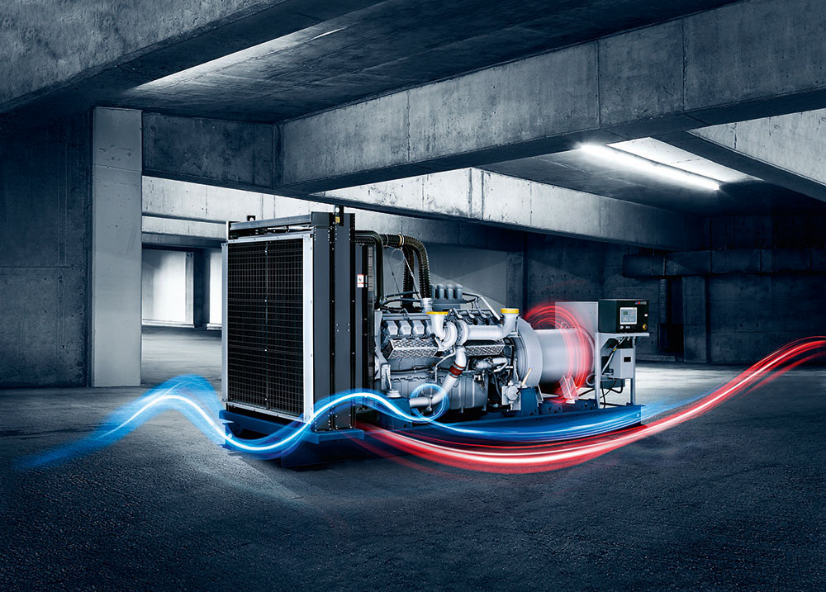Jaied & Massoud Trading Co. Ltd, is one of the main backer in the Yemeni Economy.

Full range of diesel generator sets.

View our power ratings. Industry leading 85% average load factor over 24 hours, and completely engineered solution from 28 KVA up to 3400 KVA.

**Read more**

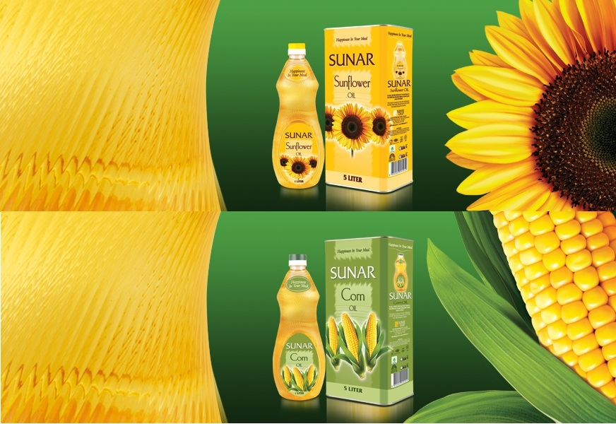

## Sunflower oil manifests its lightness withs its appearance and taste.

## Sunar Corn Oil differs from other edible oils with its distinctive flavor and unique taste.

## Read more

# Fakir - the subtle difference

**products with the best quality, highest reliability and durability of a model**

**Read more**

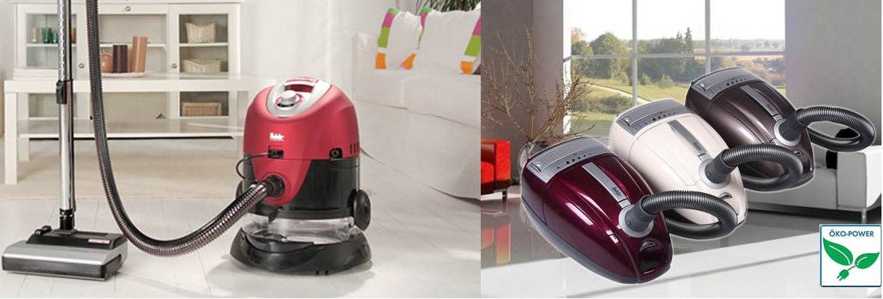

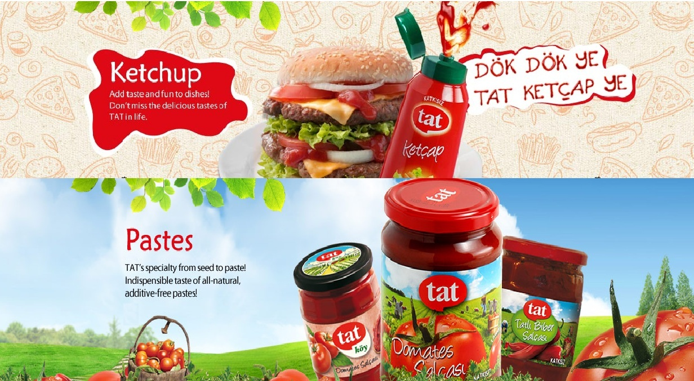

Read more

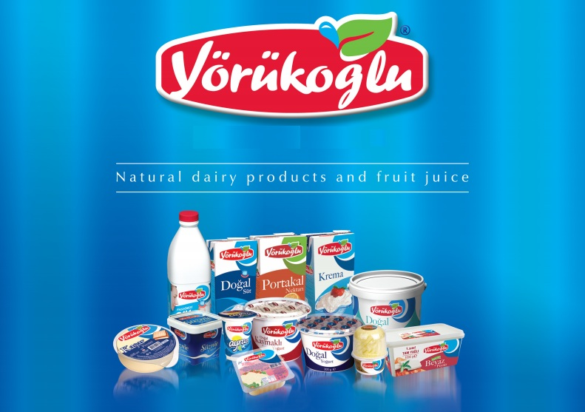

Yörükoğlu, confidence, full of flavor and health! guarantees its fresh milks

**Read more**

# Fakir - the subtle difference

**products with the best quality, highest reliability and durability of a model**

**Read more**

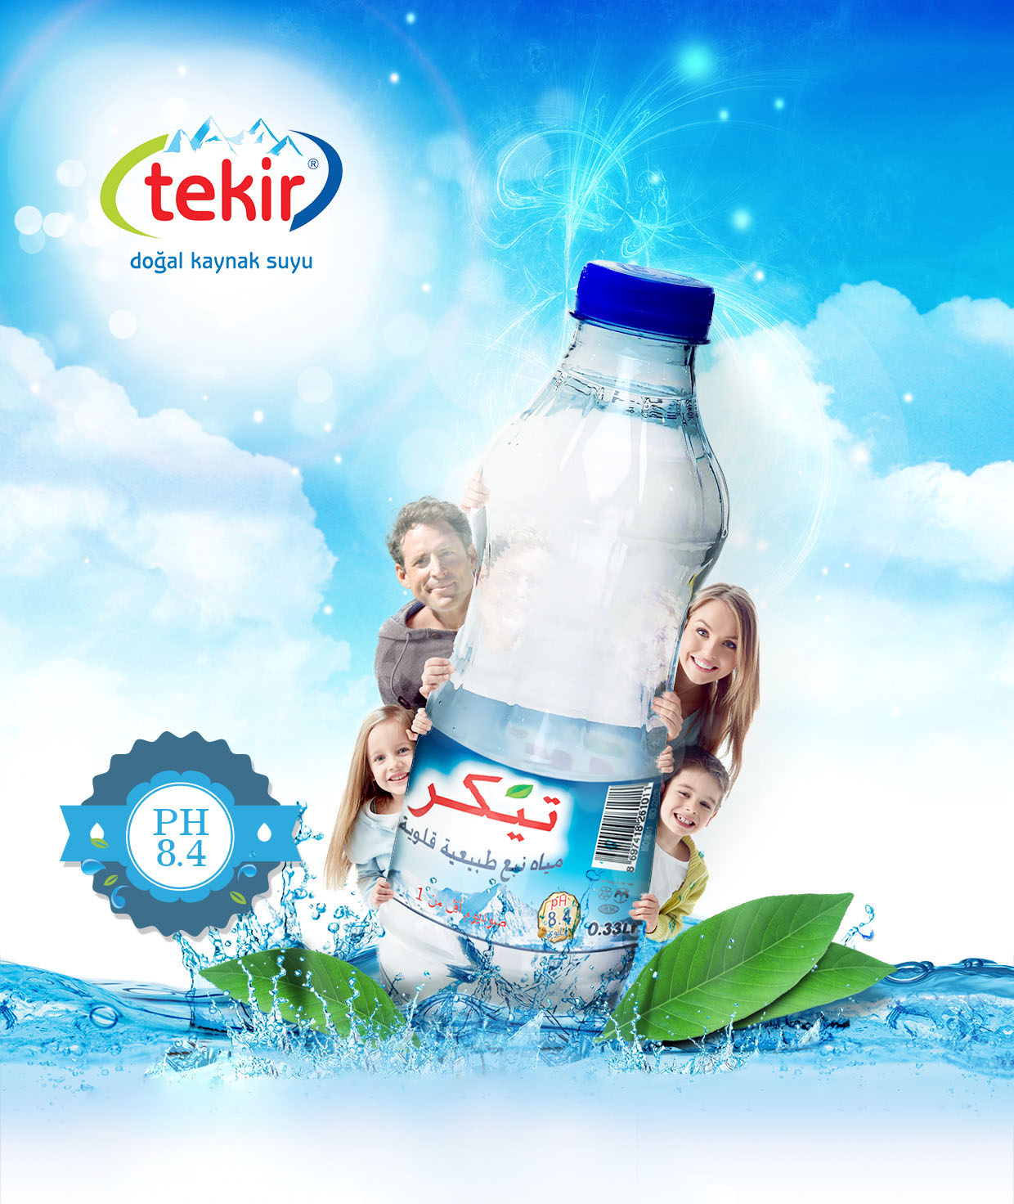

Tekir water with its high alkalinity (ph), high ratesof calcium and low sodium level is rarely found for human health.

Read more

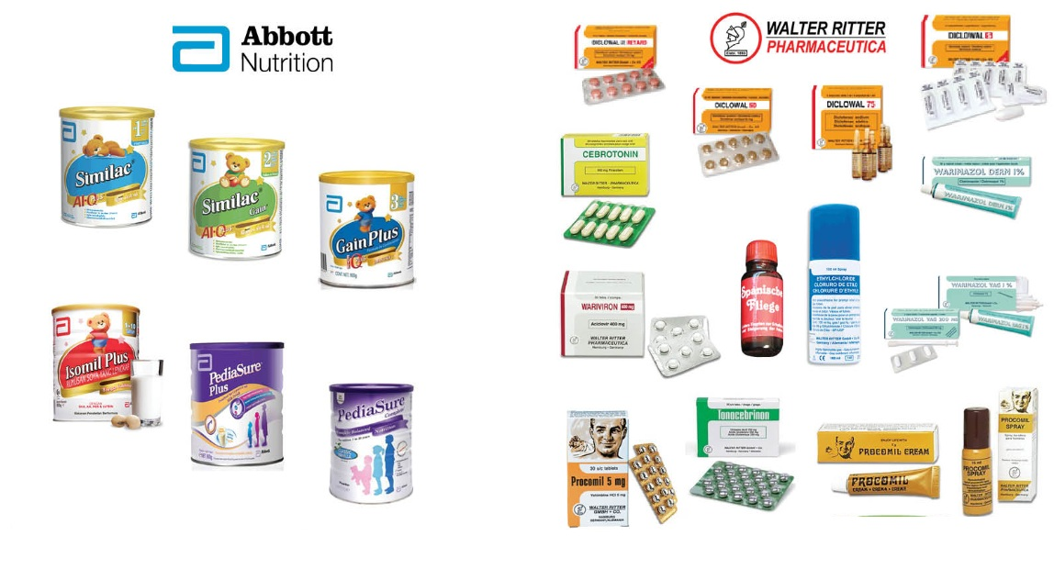

Production follows the strict German pharmaceutical law and the guidelines stipulated by the regulations of **GMP** (good manufacturing practice) to guarantee the **high standard and safety** of our pharmaceutical products.

When it comes to the science of nutrition, Similac® stands apart. For more than 85 years, the makers of Similac have been dedicated to giving moms and babies a strong start.

Read more

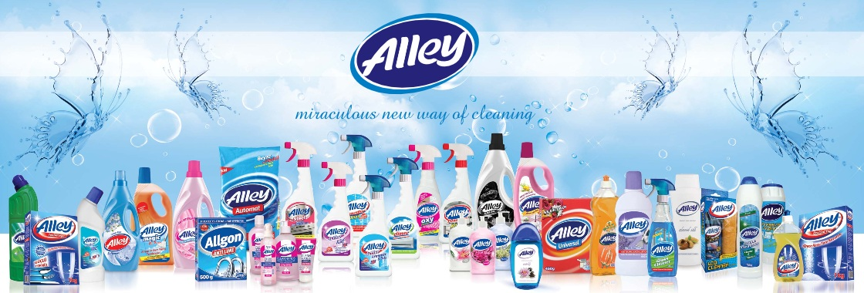

Advanced cleaning power by Alley

Read more

شعار الشركة

